Welcome!!
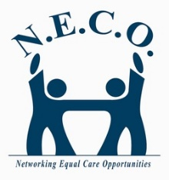 NECO NEWS
Networking Equal Care Opportunities-Lucas County |  | 1/1/2017 | 1.2017 vol. 1

Consumer Spotlight
• • •
Mike Baran
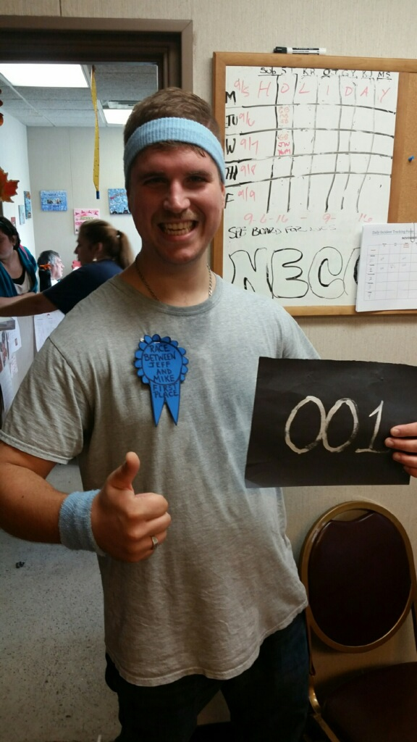
Mike has been a consumer with NECO since June, 2011.
Mike, sometimes known as “Mikey” says his proudest accomplishment has been beating Jeff (Deckebach) in a 3-mile race and getting his alone time. His favorite hobbies are track, swimming and watching movies. In particular, he enjoys action
…..continued on page 3
  - Jeff Deckebach, Executive Director

Welcome to our first NECO newsletter. We will be sending this out every quarter.
The objective of the newsletter is to make sure we are communicating relevant information with our staff and stakeholders. The newsletter will include spotlights of a particular consumer(s), changes or reminders around policies and employee benefits, things that we should be celebrating, things that we need to work on and upcoming events that might be of interest. If you would like to contribute something to the newsletter let me know.
“The objective of the newsletter is to make sure we are communicating relevant information with our staff and stakeholders.”
We will also try to include a special message from one of our staff or clients every issue. I’m doing our first message.
My topic is: Adios 2016
For me, 2016 was a crappy year. Two lifelong heroes died: Muhammad Ali and Gordie Howe.
My father in law, Darrel, also died. He was the kind of guy that took up more than his share of space in a room. He was always laughing, joking, cussing and drinking. Life won’t the same without him.
We had an insane presidential election. I know some folks are happy with the outcome but it left me in shock and actually afraid for our country. I hope I’m wrong. But I’m worried for those who struggle pay check to pay check or are at risk of being judged based on their faith, race, ethnicity or disability. What is going to happen to Medicaid and Social Security? How might that impact our clients?
By far the worst 2016 event at NECO was the death of a former client. His health was always a concern and I worried about him when he moved out of state to be with family. Within a few months of leaving we got the word that he died. I was sick to my stomach. Maybe his death couldn’t have been prevented but I couldn’t help feeling we all failed him.
On the positive side, Melissa and Jason Miller successfully started up an ADS program in Dayton and our Administrative team in Lucas County was solidified with Cathy Amburn becoming the Director of Residential Services and Amanda Byrd becoming our Residential Coordinator. Cathy has done a great job coordinating MUI responses and Amanda is developing some outstanding Site Supervisors who care deeply about our clients – it’s not just a job to them or to most of our staff and I’m proud of that. In addition, Ernest Easley has become the Director of our ADS and NMT services and his enthusiasm is beginning to show an impact as we closed out 2016 with several new ADS clients coming on board. The work that he, Keisha Ridley, George Young and many others do bodes well for our future.
In 2016 NECO was able to turn around financial losses from the last 2 years into a gain this year but money is still tight. The expansion to Dayton will pay off in the long run but startups are always costly. We are seeing some growth in Lucas and Montgomery counties already and by this summer I think we will be in great shape but it has been painful getting here. I hate worrying about money, it feels inappropriate when your mission is to serve others, but, it is a cold reality.
Consumer Spotlight-Mike Baran (cont’d from page 1).
action and sci-fi movies and playing video games. In the short term, Mike would like to apply for a job at Kroger and continue to increase his alone time. In Mike’s long-range view he’s hoping to get a driver’s license, buy a car (white Oldsmobile) and become a detective.
Mike’s father passed away in 2016 and his mother and one brother live in Toledo. His older brother lives in North Carolina.
Mike is a fan of the Charlotte Hornets and Detroit Tigers and Lions. His favorite food is pizza or a #3 combo at Wendy’s. His favorite vacation spot is Splash Bay.
Mike would like to start a foundation to reduce littering and if he had one wish it would be to have a life where he has a house, support a family as a movie star and own a boat.
Mike is a very empathetic and respectable guy with a great sense of humor. NECO is proud to support Mike as he works to reach his goals; he is a joy to serve!

Perhaps the best thing about 2016 is that due to quick staff response and medical follow up we had 3 or 4 clients that are still with us today who

Employee Spotlight
• • •
Jurlean Johnson
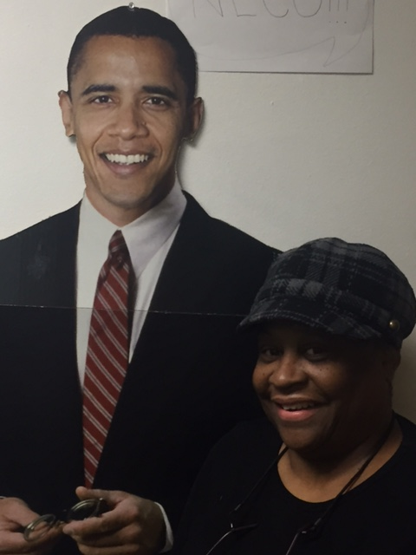
Jurlean is a NECO Residential Supervisor. She was hired with NECO in August, 2007 and started as a Medical Assistant then moved to Direct Support and into Residential Management. Jurlean has tons of compassion for consumers. Jurlean’s advice for new staff is that you have to have a lot of patience, be compassionate and concerned for the
could have easily passed away in 2016. That is a scary thing. All providers feel the pressure of this responsibility and NECO is not alone in providing supports to some extremely high risk folks. Lots of other providers did great work on behalf of their clients and I applaud them-it’s not just NECO, it’s us as a system that looks out for our population. I’m just thankful for our direct care staff, our medical staff follow up, our guardians and the medical care that our guys received when they needed it most. We can always do better, but because of all of them, 2016 won’t be the last year for these members of the NECO family.
I guess when I really think about it 2016 wasn’t that bad after all.
Wishing all of my NECO family and, all of you who care about what we do, an even better 2017.
Jeff

Upcoming Activities
• • •
January 25th – Consumer First Meeting, 6:00 – 8:00 pm
ADS 2 – 3232 South Ave.
January 28th – 29th 2017 Auto Show – SeaGate Center
Tuesday, February 14 – Valentine’s Day!

Employee Spotlight
• • •
Jurlean Johnson
Jurlean is a NECO Residential Supervisor. She was hired with NECO in August, 2007 and started as a Medical Assistant then moved to Direct Support and into Residential Management. Jurlean has tons of compassion for consumers. Jurlean’s advice for new staff is that you have to have a lot of patience, be compassionate and concerned for the Individual. Her joy at work is helping the Individuals meet goals and feels her greatest work accomplishment is when one of her Individual’s makes a step toward independence. She reminds us that this work is not about the money you earn but about the reward gained from the work.
Jurlean was born in Mississippi and has been married for 46 years. She has 3 sons and 10 grand-children; 3 sister and 6 brothers. Interestingly, Jurlean and her sister married brother; so, their children are called “double cousins” meaning they have the same family on both the mother and father’s side of the family.
Jurlean’s hobbies are cooking, baking and family gatherings. She is known around NECO for her cakes! Customer favorites are her German Chocolate and Caramel cakes.
Jurlean is known to some of her clients as “Granny”. She loves the nickname and is proud that she is viewed as part of an individual’s family. She feels empathy for those clients who don’t have family or whose family isn’t in contact.
Jurlean is NECO’s “Granny” – not just to the clients but to all of our staff. She is feisty, principled and is an example of a very high standard of care. We are grateful to have her as part of our NECO family and hope she chooses to stay with us for a long time.

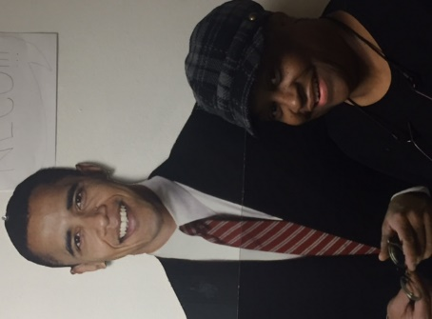
Jurlean Johnson
NECO’S New Leisure Center to Open January 23, 2017.
Neco’s new Leisure Center is opening January 23rd at the old Melissa N Miller Administration Building – 209 N. Reynolds Rd. The Leisure Center will serve retired individuals. Please contact Ernest Easley at 419-389-1101 or eeasley@neco-ohio.com for more information or if you’re interested in attending.
BIRTHDAYS
Jan 14 – Dayvon B
Jan 22 – Chico M
Jan 28 – Dan F
Feb 4 – Mike B
Feb 8 – Shirlyn S
Feb 14 – Sheldon C
Larry D
Isaiah B
Mike B

Thanks to Everyone!! Thanks to everyone who has responded to Neco’s request for constructive feedback on our service delivery. It’s not too late to respond if you haven’t done so!! Please e-mail Cathy Amburn at camburn@neco-ohio.com with your feedback and any recommendations you have for Neco to improve our service.

Who’s Who at Neco??
Jeff Deckebach, Executive Director. mailto:jdeckebach@neco-ohio.com
Cathy Amburn, Director, Residential Program Services. mailto:camburn@neco-ohio.com
Ernest Easley, Director, Neco Lucas County ADS and NMT Services. eeasley@neco-ohio.com
Amanda Byrd, Residential and Medical Coordinator. mailto:amathis@neco-ohio.com.
Sue King, Director, HR, Finance and Administration. mailto:hr@neco-ohio.com
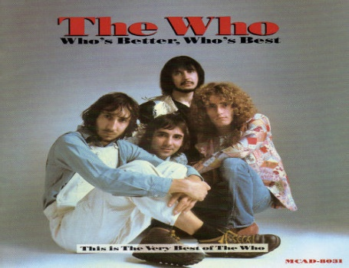

NECO hopes everyone stays healthy and encourages you to get your flu shot!

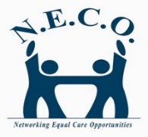
Networking Equal Care Opportunities
Lucas County: 209 N. Reynolds Rd., Toledo, OH 43615 (419) 389-1101
Montgomery County: 4204 E. River Rd., Moraine, OH 45439 (937) 296-9249
Questions or Comments: Call or email: 419-389-1101 jdeckebach@neco-ohio.com or Editor Susan King at 419-389-1101 hr@neco-ohio.com

NECO is always looking for qualified staff. Remember our Employee Referral bonus is $75 after the new hire works 45 days!
ATTENTION NECO EMPLOYEES!!
The Ohio Department of Developmental Disabilities requires that all staff who work with DD individuals maintain certification in CPR/1st Aid, Medication Administration, and CPI. While Neco tracks your training certifications and offers the classes, it is ultimately YOUR responsibility to maintain your certifications and work eligibility.
If you missed the Neco All Staff meeting on Tuesday, January 17, 2017; please contact Talesa at 419-389-1101 to schedule viewing of the video. This All Staff meeting included mandatory training on MUI, Bill of Rights, Abuser Registry and Attestation training required annually for all staff. We don’t want anyone taken off the schedule so please be sure to make time for this important training.

